|  |  |  |  |  |  |
| --- | --- | --- | --- | --- | --- |
| Date | 7-Dec-22 | | | Tester Name | Richard Belanger |
| Environment | Select Environment | | | Login used | Test 2 |
| Operating System | Select OS | Version: | Update: | | |
| Software Used | Edge | Version: | Update: | | |
| Select Software | Version: | Update: | | |
| Release version | 22.4.1 | | | | |
| Title | M19.01 Payout Holdback Funds, check interest allocated | | | | |
| Test Type | Regression | | | | |
| Test Scenario | Pay out a Member’s holdback payment, verify interest applied | | | | |
|  |  | | | | |
| Expected Results | Holdback will be paid out with correct interest applied | | | | |
| Pass/Fail | Pass | | | JIRA# | N/A |

Describe your steps with screenshots:

Member has Holdback payable October 3, 2022>Payment Instructions added>Approved

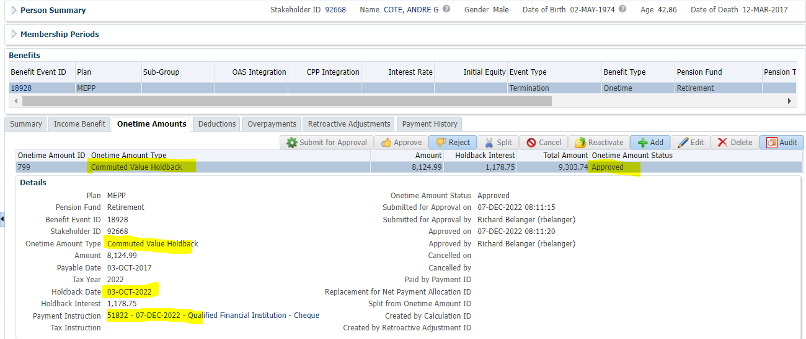

Payment History>Member paid Holdback

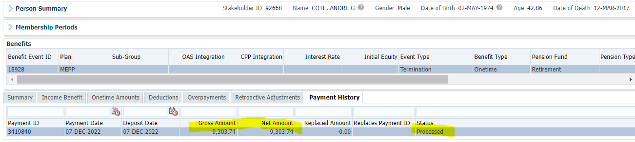

Paid

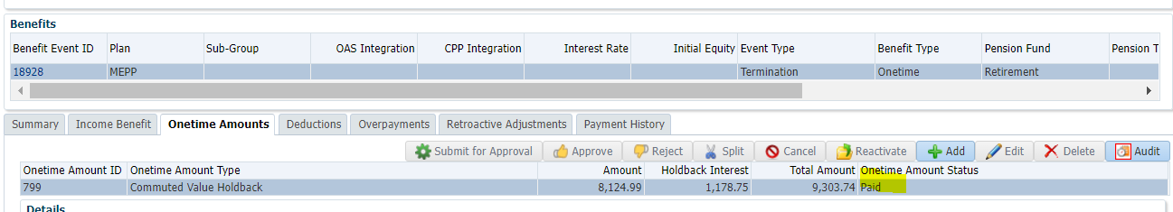

Member has Holdback payable October 3, 2022>Payment Instructions added>Approved

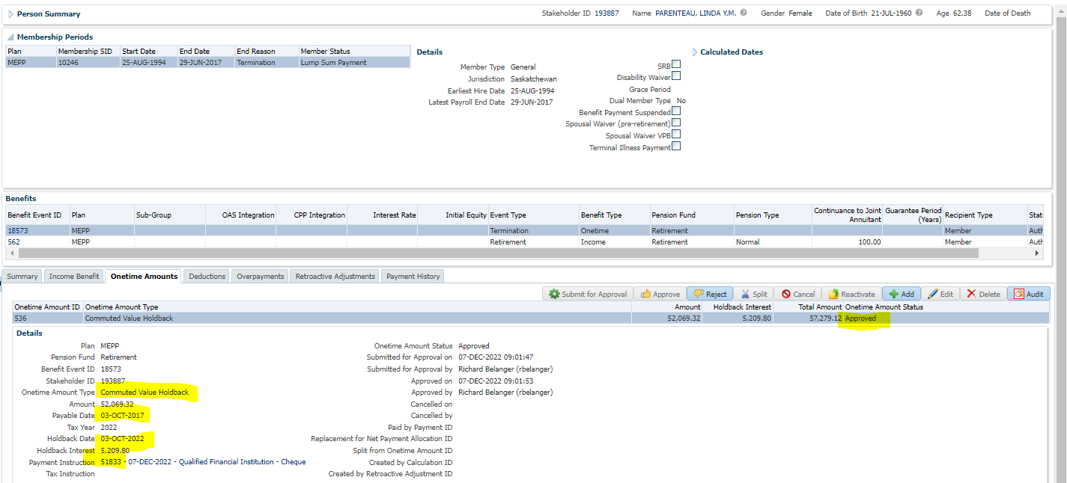

Payment History>Member paid Holdback

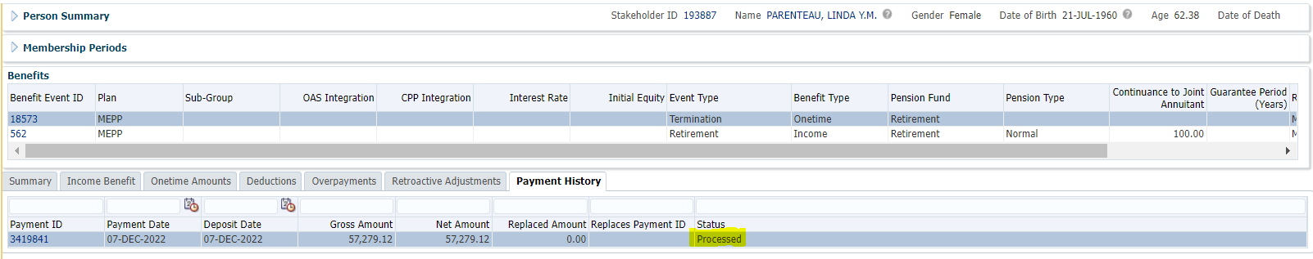

Paid

